# JS Fundamentals: Test Exam

*This is a test exam for course* [*JavaScript Fundamentals*](https://softuni.bg/courses/javascript-fundamentals) *at SoftUni.*

## Problem Stadium

*It is time for the match between Levski and Litex. Your task is to distribute all the fans to the sectors of the team there are for.*

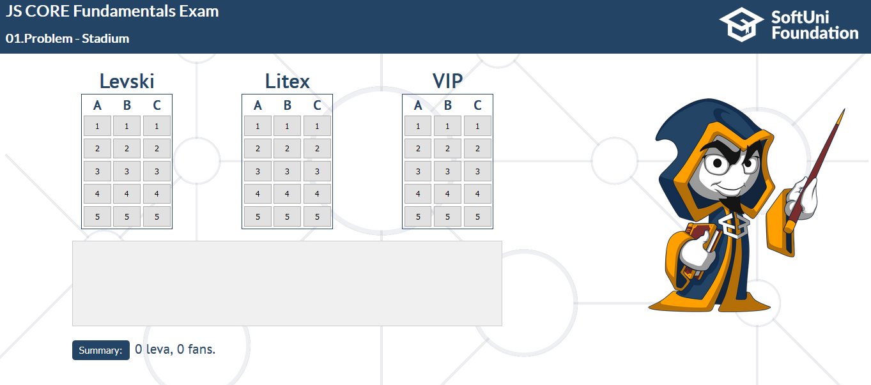

There are **3 types of sectors**: **"A"**, **"B"** and **"C"**, and **3 types of zones**: **"LITEX"**, **"LEVSKI"** and **"VIP"**. Your job is to finish this program to works as expected:

When someone want to buy a ticket (**click on specific seat**), you get a particular amount of **money** depending on the sector and whether the zone is **LEVSKI/LITEX** or **VIP**. Follow the table below:

|  |  |  |
| --- | --- | --- |
|  | **LEVSKI/LITEX** | **VIP** |
| **A** | 10 | 25 |
| **B** | 7 | 15 |
| **C** | 5 | 10 |

When that’s happen, you need to **mark** that seat as **already taken**. And print the expected message in the **textarea**.  
If the current seat is **available** - **Seat {seatNumber} in zone {team/VIP} sector {sector} is was taken.**  
If the current seat is **unavailable - Seat {seatNumber} in zone {team/VIP} sector {sector} is unavailable.**

**To mark that seat as taken you need to make the button a rgb(255,0,0) color.**For example, if we click over the seat **3** in zone **VIP** sector **C**, the expected result should be:

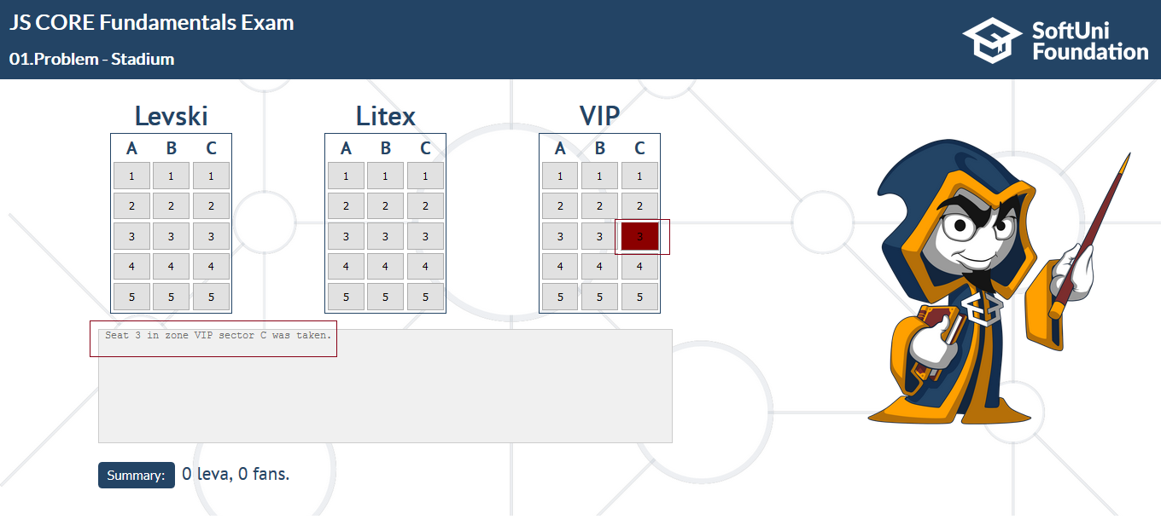

And if we click **again** at the **same seat**, the **expected** **result** should be:

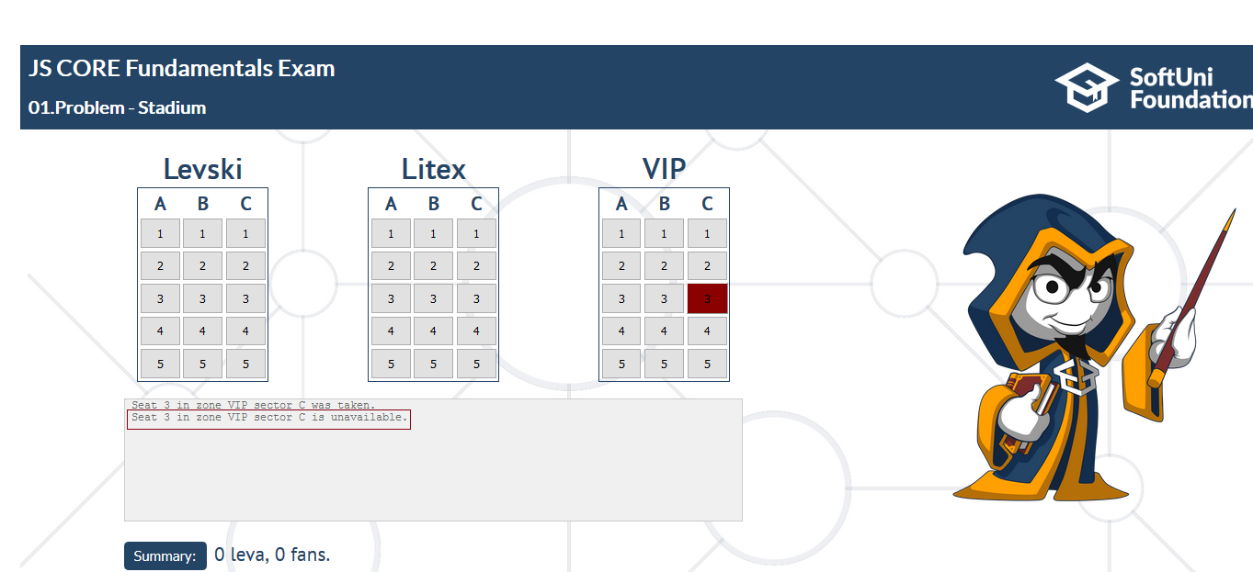

**Note: You must keep track of the profit of all tickets sold and the number of all fans.**

**If the ‘Summary’ button is clicked. You should print the profit of all tickets and the number of all fans, as shown below.**

### Examples

**Sequence of clicks - LITEX 5 A -> LITEX 5 B -> LITEX 5 A -> VIP 1 A**

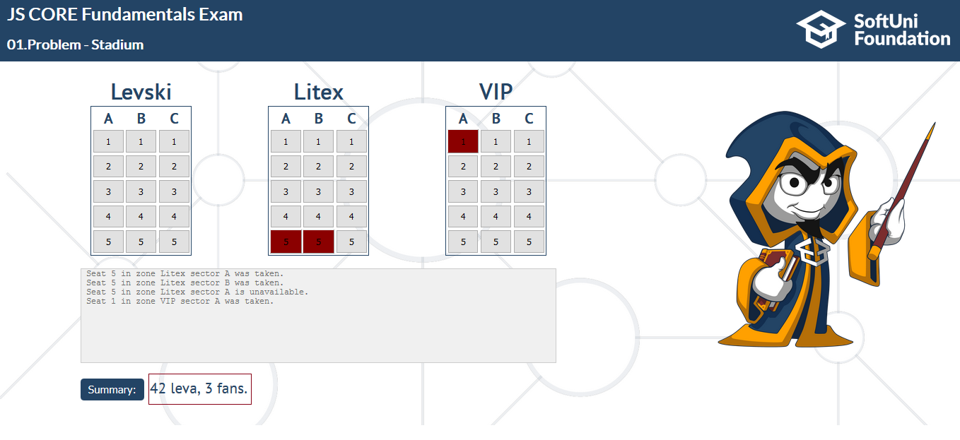

**Sequence of clicks - LITEX 5 A -> LEVSKI 2 A -> LEVSKI 3 B -> VIP 4 C -> LITEX 3 B -> LEVSKI 2 A ->  
LITEX 5 B -> LITEX 5 A -> VIP 1 A**

